OOP Homework Four

Content
Problem 1 . . . . . . . . . . . 2~9
（一） number generator generate . . . . . . . . .. . .2
（二） find_value() . . . . . . . . . . . . . . . . . . . . . . 3~4
（三） Program of main . . . . . . . . . . . . . . . . . . . .4~6
（四） Running result . . . . . . . . . . . . . . . . . . . . . .6~8

Problem 2 . . . . . . . . . . . 10~12
（一）Topic . . . . . . . . . . . . . . . . . . . . . . . . . . . . . 10
（二） Information . . . . . . . . . . . . . . . . . . .. . . . . .11
（三） Rewrite this program . . . . . . . . . . . . . . .. . .11
（四） Other states . . . . . . . . . . . . . . . . . . . . . . . .. 12
--------------------------------------------------------------------------------------------------------------------------------------------
Problem One
--------------------------------------------------------------------------------------------------------------------------------------------
- At first, I write a program that is number generator generate “a”, ”b” and ”c”, numbers ranging from 0 to 10000, and then write out to “number.txt”.
（一）Flow chart：
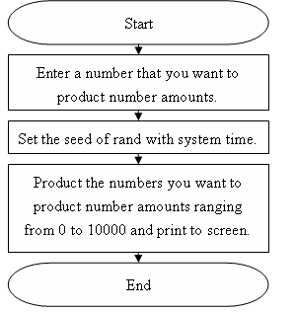
（二）Program（number.c）：
----------------------------------------Program code start----------------------------------------
#include <stdio.h>
#include <stdlib.h>
#include <time.h>
main()
{
printf("\n---------------∮This program is-★-B9502028-★-陳敬翔-create∮---------------\n");
FILE *wr_file;
wr_file=fopen("number.txt","wt");
if(wr_file==NULL)
{
printf("File can not creat!");
getch();
return 0;
}
printf("File can save and load.\nStart the flie write\n");
srand((unsigned)time(NULL));
fprintf(wr_file,"a=%3d b=%3d c=%3d\n",rand()%10001,rand()%10001,rand()%10001);
printf("File is already writed to number.txt!\n");
fclose(wr_file);
system("PAUSE");
return 0;
}
----------------------------------------Program code end----------------------------------------
二、And program a function of topic requesting “find_value()”, I use the way of selection sort, and add to project of statistic.
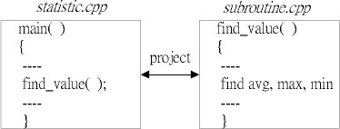
- Flow chart：
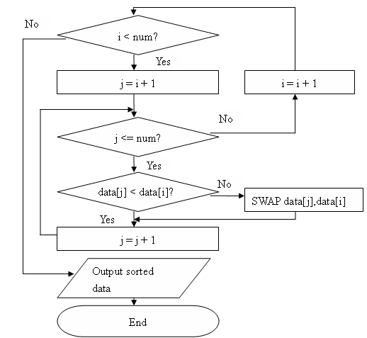
（二）Diagram of notion：
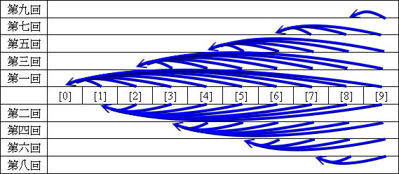
（三）Program（subrotine.c）：
----------------------------------------Program code start----------------------------------------
void find_value(int* number)
{
short i,j,temp; /*"i" and "j" are used when loop, and "Temp" is used when two variable change.*/
for(i=0;i<2;i++)
{
for(j=i+1;j<=2;j++)
{
if(*(number+i)>*(number+j))
{
temp=*(number+i);
*(number+i)=*(number+j);
*(number+j)=temp;
}
}
}
}
----------------------------------------Program code end----------------------------------------
三、Main of program “statistic.c” start
（一）Flow chart：
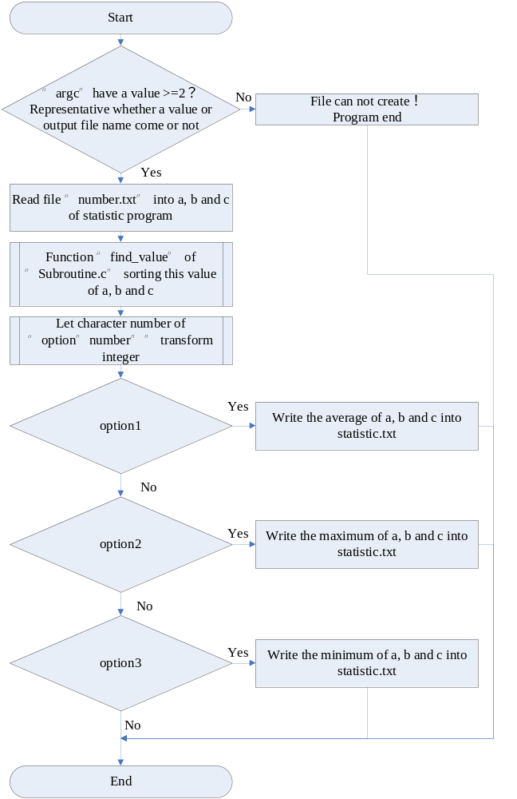
（二）Main program（statistic.c）：
----------------------------------------Program code start----------------------------------------
#include<stdio.h>
#include<stdlib.h>
int my_atoi(char* cha) /*Creat a function of string into integer.*/
{ /*Using transforming charator "option "number"" of "argv".*/
short i;
for(i=0;i<10;i++)
{
if((*(cha+i)>='0')&&(*(cha+i)<='9'))
{
return (int)*(cha+i)-48;
}
}
}
int main(int argc, char* argv[]) /*This program need use "argc" and "argv" to decide to do which options.*/
{
printf("\n---------------∮This program is-★-B9502028-★-陳敬翔-create∮---------------\n");
FILE *rd_file,*wt_file; /*Creat two file "rd_file" to do read and "wt_file" to do write.*/
int number[3],argc_for; /*"Number[0]" is a, "number[1]" is b, "number[2]" is c, "argc_for" is used when print variable of "argc" and "argv".*/
char text_a[3],text_b[3],text_c[3]; /*Name of a, b, and c.*/
printf("Region of test:\nargc=%d\n\nargv:\n",argc);
for(argc_for=0;argc_for<argc;argc_for++) /*Print variable of argc and argv.*/
{
printf("%d:\n%s",argc_for,argv[argc_for]);
}
printf("\n--------------------Information of data--------------------\n");
if(argc>=2) /*If there is a value, argc is not zero. Write corresponding value "argv" of "argc".*/
{
rd_file=fopen(argv[1],"rt");
}
else
{
printf("Can not open file to write!\n");
getch();
return 0;
}
wt_file=fopen("result.txt","wt");
if((rd_file==NULL)||(wt_file==NULL)) /*If file can not get, end program.*/
{
printf("Can not open file to read or write!\n");
getch();
return 0;
}
fscanf(rd_file,"%s %d %s %d %s %d",&text_a,&number[0],&text_b,&number[1],&text_c,&number[2]); /*Get values of a, b and c.*/
printf("Data are : %s%3d %s%3d %s%3d\n",text_a,number[0],text_b,number[1],text_c,number[2]); /*Print values of a, b and c.*/
find_value(&number); /*Small sortting function "find_value".*/
printf("Average is %.3f\nMaximum is %3d\nMinimum is %3d\n--------------------Wrote of data--------------------\n",(float)(number[0]+number[1]+number[2])/3,number[2],number[0]);
printf("---------------∮This program is-★-B9502028-★-陳敬翔-create∮---------------\n"); /*Print information of a, b and c.*/
fprintf(wt_file,"---------------∮This program is-★-B9502028-★-陳敬翔-create∮---------------\n");
if(argc>=4) /*If there is a value, argc is not zero.*/
{ /*At this time, we can select option 1, 2 or 3.*/
if(my_atoi(argv[3])==1)
{
fprintf(wt_file,"Average is %.3f",(float)(number[0]+number[1]+number[2])/3);
printf("Average is %.3f",(float)(number[0]+number[1]+number[2])/3);
}
if(my_atoi(argv[3])==2)
{
fprintf(wt_file,"Maximum is %3d",number[2]);
printf("Maximum is %3d",number[2]);
}
if(my_atoi(argv[3])==3)
{
fprintf(wt_file,"Minimum is %3d",number[0]);
printf("Minimum is %3d",number[0]);
}
}
printf("\n--------------------Wrote end--------------------\nFile is already wrote to result.txt!\n");
fclose(rd_file); /*Program end, file close.*/
fclose(wt_file);
getch();
return 0;
}
----------------------------------------Program code end----------------------------------------
Roughly, we can easy to know this program designed principle by flow chart and remember note, and add to project of statistic.
四、Running result：
（一）number generator generate（number.c）：
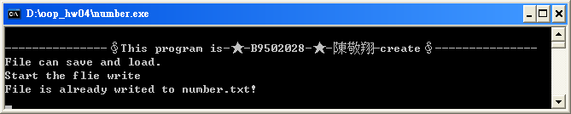
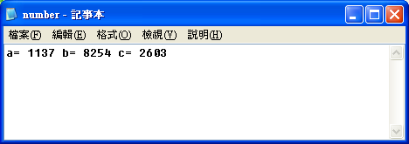
（二）Main program（statistic.c）：
Ⅰ、It can not open file to write, because “argc” have not a entry value, we have to operation in DOS or UNIX.
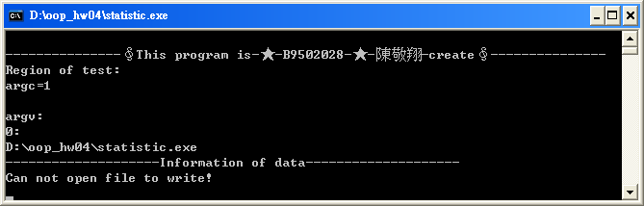
Ⅱ、Option1：
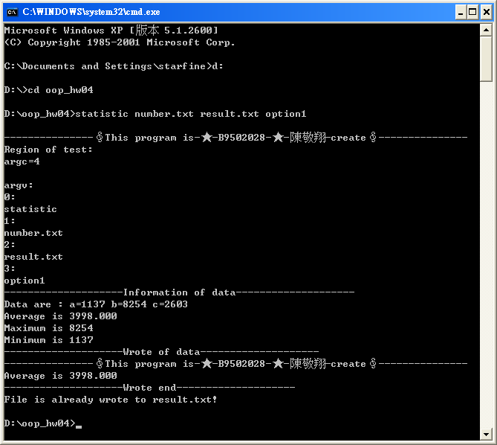
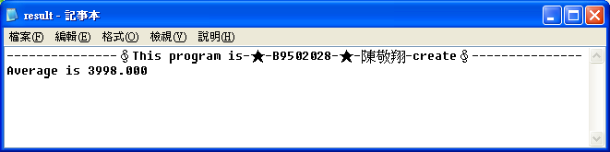
Ⅲ、Option2：
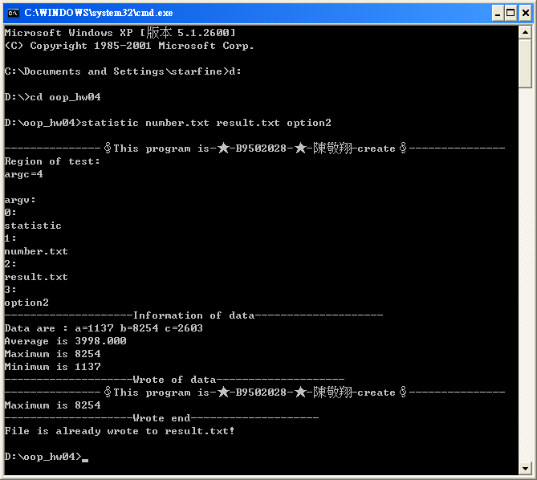
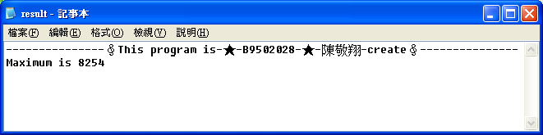

Ⅳ、Option3：
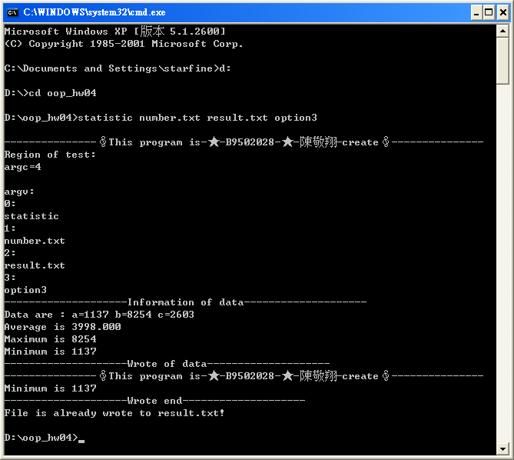
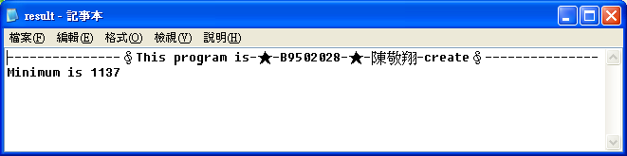
--------------------------------------------------------------------------------------------------------------------------------------------
Problem Two
--------------------------------------------------------------------------------------------------------------------------------------------
- Rewrite the following program by modifying structure into class, and include the subroutine as a member function.
（一）program code(struct.c)：
----------------------------------------Program code start----------------------------------------
#include <stdio.h>
struct personal_info
{
unsigned int age;
unsigned int weight;
char *name;
};
struct personal_info info_diff(struct personal_info people_a, struct personal_info people_b)
{
struct personal_info inf_dif_sub;
inf_dif_sub.age=people_a.age-people_b.age;
inf_dif_sub.weight=people_a.weight-people_b.weight;
return(inf_dif_sub);
}
int main()
{
struct personal_info people[2]={{33, 70, "George"},{18, 45, "Mary"}};
struct personal_info inf_dif;
inf_dif=info_diff(people[0], people[1]);
printf("Differences between %s and %s\n",people[0].name, people[1].name);
printf("Age:%2d Weight:%2d\n",inf_dif.age, inf_dif.weight);
getch();
return 0;
}
----------------------------------------Program code end----------------------------------------
（二）Running result：
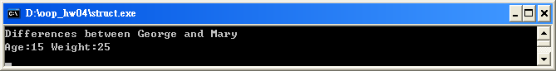
二、Information：
（一）It is "public" that "struct" preserve the level of protecting.
（二）It is "private" that "class" preserve the level of protecting.
（三）Because "class" preserve the level of protecting is private, need to set up public level in addition.
（四）“Public” is defined public, so we can use the data member directly.
（五）“Private” is defined private, so we have to set member function to indirect storage.
三、Rewrite this program (struct_into_calss.cpp)：
（一）program code(struct.c)：
----------------------------------------Program code start----------------------------------------
#include <iostream.h>
class personal_info /*It is "public" that "struct" preserve the level of protecting.*/
{ /*It is "private" that "class" preserve the level of protecting.*/
public: /*Because "class" preserve the level of protecting is private,*/
{ /*need to set up public level in addition.*/
unsigned int age;
unsigned int weight; /*The following struct change into class*/
char *name;
}
};
class personal_info info_diff(class personal_info people_a,class personal_info people_b)
{
class personal_info inf_dif_sub;
inf_dif_sub.age=people_a.age-people_b.age;
inf_dif_sub.weight=people_a.weight-people_b.weight;
return(inf_dif_sub);
}
int main(void)
{
class personal_info people[2]={{33, 70, "George"},{18, 45, "Mary"}};
class personal_info inf_dif;
inf_dif=info_diff(people[0], people[1]);
cout << "Differences between " << people[0].name << " and " << people[1].name << endl;
cout << "Age:" << inf_dif.age << " Weight:" << inf_dif.weight << endl;
getchar();
return 0;
}
----------------------------------------Program code end----------------------------------------
（二）Running result：
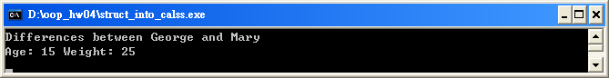
四、Other states：
If you want to use preserve of "class", because this preserve is "private", you have to set member function to indirect storage.
You can set class it in this way:
----------------------------------------Program code start----------------------------------------
typedef class personal_info /*It is "public" that "struct" preserve the level of protecting.*/
{ /*It is "private" that "class" preserve the level of protecting.*/
unsigned int age; /*If you still want to use preserve of "class", because this preserve is "private",*/
unsigned int weight; /*you have to set member function to indirect storage.*/
char *name;
public:
{
void set(unsigned int in_age,unsigned int in_weight,char *in_name)
{
age=in_age;
weight=in_weight;
*name=*in_name;
}
unsigned int get_age(void)
{
return age;
}
unsigned int get_weight(void)
{
return weight;
}
char* get_name(void)
{
return *name;
}
}
}per;
----------------------------------------Program code start----------------------------------------

